
Software Development Course

Software Development Course - FizzBuzz Challenge
Practical programming challenge

Evidence Collection

Document overview
This document records the source code, program execution and automated test results for the FizzBuzz challenge. The numbered annotations show exactly where each requirement is implemented or demonstrated.
Course information | Details
Course | Software Development
Document type | College evidence collection
Learner | Rob Johnston
Unit | FizzBuzz Challenge
Assessment | Practical programming challenge
Assessor | Alex Richards
Submission date | 28/09/2026

Evidence location
Evidence area | Verified location
Course folder | E:\OG-SCUF641_FullDataTransfer_2026-07-15_FINAL\DATA\C\OGBuild\College\  Software Development L3\New folder
Source code | fizzbuzz.py in the course folder above
Supporting files | test_fizzbuzz.py in the course folder above
Video evidence | Not required for this challenge

Assessment criteria covered
Criterion | What the criterion requires
Task 1 | Accept a whole number from 1 to 100 and produce fizzbuzz when it is divisible by both 5 and 3.
Task 2 | Produce fizz when the number is divisible by 5 and buzz when it is divisible only by 3.
Task 3 | For any other valid number, print that the number is not divisible by 3.
Verification | Show the source code running and provide traceable test evidence for the required branches and the range check.

Evidence record
Reference and criterion | Evidence | My explanation of what it proves
E01 / Tasks 1-3 | Figure 1 - annotated source code in Visual Studio Code | Shows range validation, decision order, input handling and the main entry point.
E02 / Tasks 1-3 | Figure 2 - annotated program execution | Shows fizzbuzz, fizz, buzz, the other-number message and the out-of-range response.
E03 / Verification | Figure 2 - automated test summary | Shows five tests ran and the result was OK.
E04 / Verification | fizzbuzz.py | The submitted Python source file used for the execution shown in Figure 2.
E05 / Verification | test_fizzbuzz.py | The submitted unit-test file covering each required branch and the upper-range rejection.
E06 / All | FizzBuzz Challenge Answer Sheet.docx | Explains the implementation decisions and links the response to this evidence collection.

Evidence item E01 Annotated source code
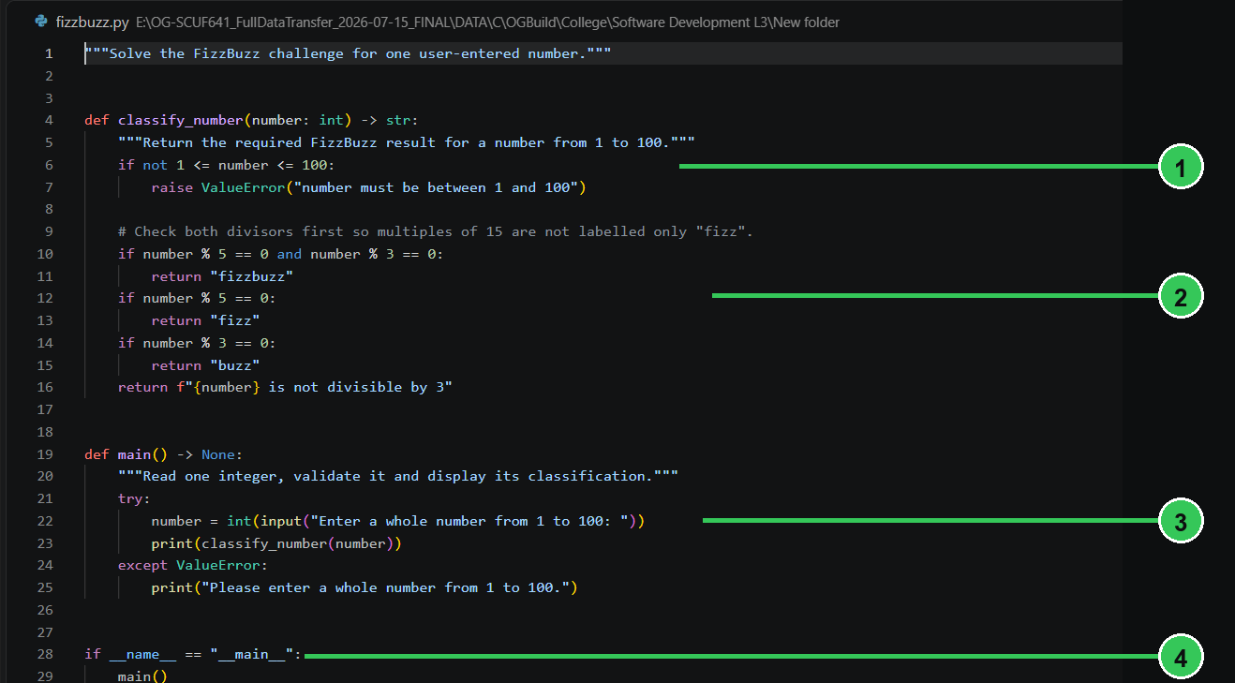
Figure 1. FizzBuzz source code open in Visual Studio Code.
Marker | What the annotation shows
1 | Lines 6-7 enforce the permitted range of 1 to 100 before any classification is returned.
2 | Lines 10-16 apply the conditions in the correct order: both divisors, 5 only, 3 only, then the other-number message.
3 | Lines 21-25 collect the integer, call classify_number, print the result and handle invalid or out-of-range input.
4 | Lines 28-29 call main only when fizzbuzz.py is run as the program entry point.

Evidence item E02 Program execution and test results
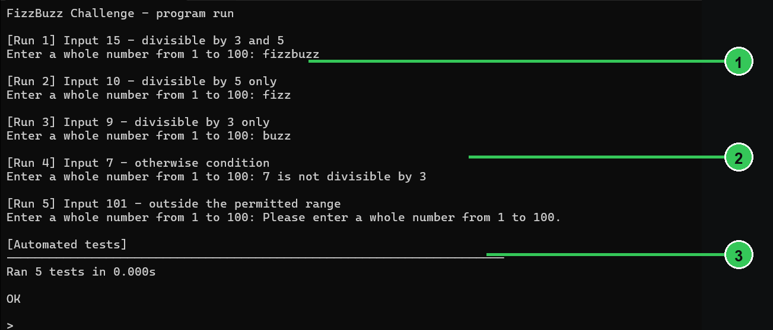
Figure 2. Program output for representative inputs followed by the automated test summary.
Marker | What the annotation shows
1 | Inputs 15, 10 and 9 produce fizzbuzz, fizz and buzz respectively, demonstrating the three divisibility branches.
2 | Input 7 produces the required other-number message, while 101 is rejected because it is outside the accepted range.
3 | The unit-test command ran five tests and returned OK, confirming that all defined automated checks passed.

Evidence integrity statement
All screenshots in this document were captured from the submitted files in the course folder listed on page 1. The program outputs and test result were produced by running those files on 28/09/2026.

